LAB ASSIGNMENT 8.1
Name: V. Rajeev Kalyan
Hall Ticket: 2403a51324
Batch: 13
Task Description #1 (Password Strength Validator – Apply AI in
Security Context):
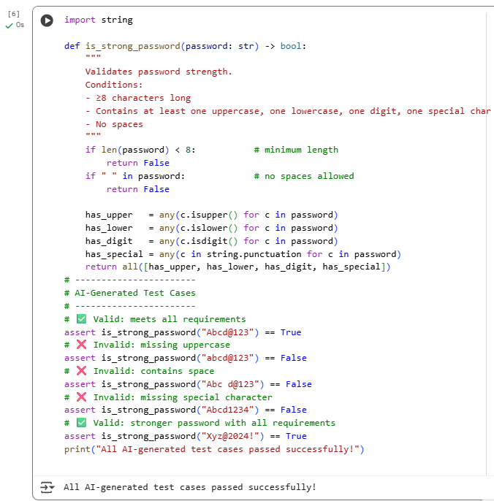
Observation:
The is_strong_password function correctly enforces all the specified password-strength rules. It first checks that the password length is at least eight characters and that no spaces are present. Then it separately verifies the presence of at least one uppercase letter, one lowercase letter, one digit, and one special character from Python’s string.punctuation. Only if all these criteria are satisfied does the function return True. The accompanying assert test cases thoroughly validate different scenarios: a valid password that meets every rule, passwords missing an uppercase letter, passwords containing spaces, passwords missing a special character, and another strong password meeting all requirements. Together, the implementation and test cases demonstrate a reliable and comprehensive approach to password validation.
Task Description #2 (Number Classification with Loops – Apply AI for
Edge Case Handling):
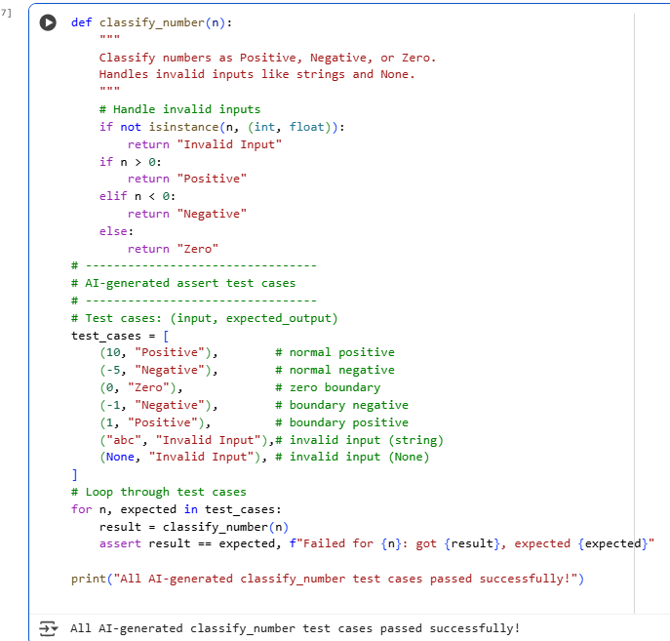
Observation:
The classify_number function correctly distinguishes positive, negative, and zero values while safely handling invalid inputs such as strings and None. It uses simple conditional checks to classify numbers and a type check to prevent errors from non-numeric values. The AI-generated test cases include normal inputs (positive and negative numbers), boundary conditions (-1, 0, 1), and invalid data types to ensure comprehensive coverage. By iterating through the test cases in a loop, the code verifies that the function behaves as expected for every scenario. This demonstrates a robust and reliable implementation of the classification logic.

Task Description #3 (Anagram Checker – Apply AI for String Analysis):
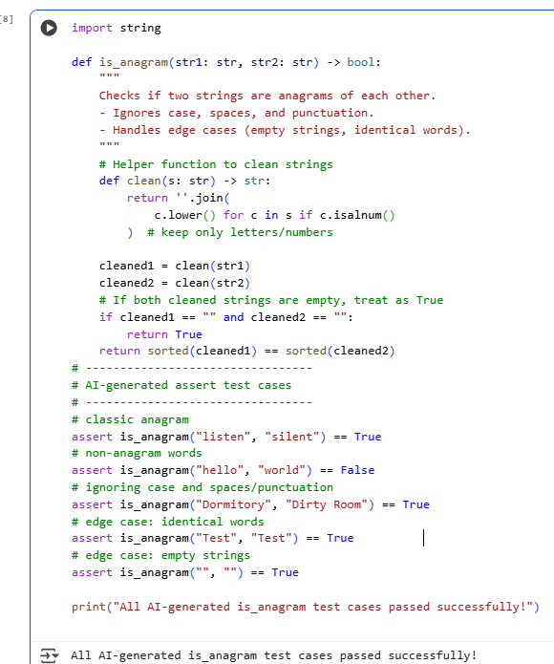
Observation:
The is_anagram function effectively determines whether two strings are anagrams by first cleaning them—converting to lowercase and removing spaces and punctuation—so that formatting differences do not affect the result. It handles typical cases like "listen" vs "silent", ignores letter casing and spaces in phrases such as "Dormitory" vs "Dirty Room", and correctly identifies non-anagrams like "hello" vs "world". Edge cases, including identical words and empty strings, are also correctly handled. The AI-generated assert test cases comprehensively validate these scenarios, demonstrating that the function reliably identifies anagrams under various input conditions.

Task Description #4 (Inventory Class – Apply AI to Simulate Real-
World Inventory System):
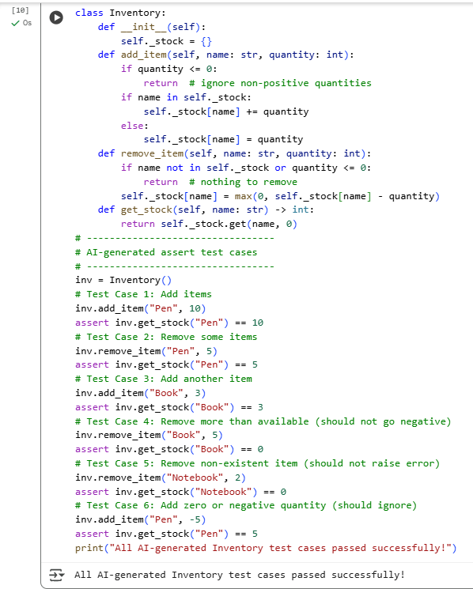

Observation:
The Inventory class provides a simple yet robust stock management system with methods to add, remove, and query stock quantities. The add_item method safely updates stock for existing items or initializes new items. The remove_item method ensures stock never becomes negative and handles non-existent items gracefully. get_stock reliably returns the current quantity or 0 if the item does not exist. The AI-generated assert tests cover typical usage, boundary conditions (removing more than available), invalid operations (negative or zero quantities), and non-existent items, demonstrating that the class behaves correctly under various scenarios.
Task Description #5 (Date Validation & Formatting – Apply AI for
Data Validation):
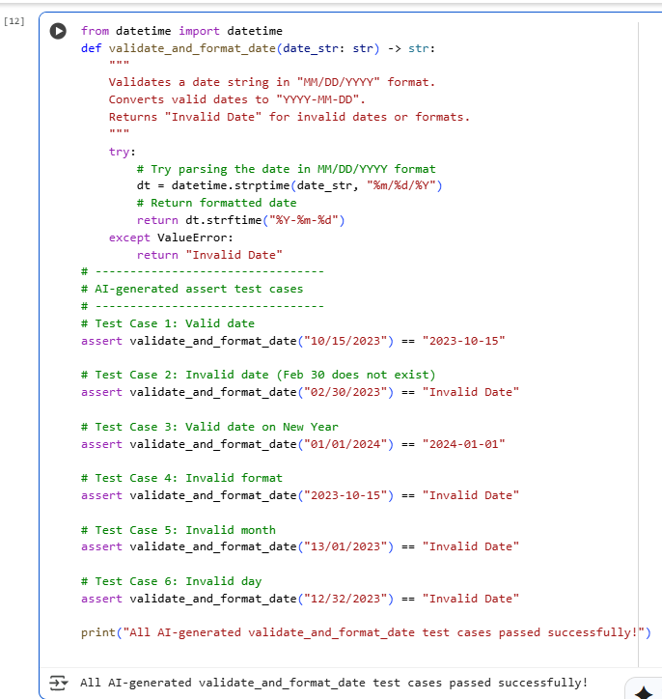
Observation:
The validate_and_format_date function ensures robust date validation and formatting. It uses Python’s datetime.strptime to parse input in "MM/DD/YYYY" format and catches invalid dates or improperly formatted strings via ValueError. Valid dates are reformatted to "YYYY-MM-DD". The AI-generated assert test cases include valid dates, invalid dates (like February 30), edge cases (New Year), and incorrect formats. This ensures that the function handles both standard and boundary scenarios correctly, reliably distinguishing valid dates from invalid inputs.

